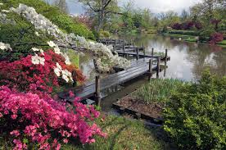

A 2015 graduate at Farmingdale State College. Majored in Biology and is studying to become a Physician Assistant.

**Edited and Revised by Bartlomiej Olko**

Class of 2017 at Stony Brook University studying to become a neurologist.

## Emily Rodrigues

# Contributors:

Organic Gardening To Sustain A Healthy Lifestyle

**Amityville Community Center**

600 Albany Avenue

Amityville, NY 11701

(631) 464-4314

# Thanks to:

Executive Director:

Greta Guarton

Director, Social Science Research Institute:

Dr. Miriam K. Deitsch

Program Coordinator:

Eva Pearson, MA

Farmingdale State College

2015

**To The Long Island Coalition for the Homeless**

#### The Long Island Coalition For The Homeless

**72**

**How to Prepare Yourself For Gardening**

### Plan your gardening schedule in advance

### Never spend too long on any one task

### Warm up before going outside

### Wear appropriate clothing

### Use sunblock

### Adapt your tools so you can keep your back straight

### Squat down instead of bending over

### Lift heavy objects with a straight back by bending the knees

**Best wood to use to build a vegetable and fruit bed**

Cedar Wood 1

**Tips and Tricks for Successful Gardening**

5-5-5 Organic Fertilizer and Seaweed 2

Homemade Fertilizer, Natural Herbicides, and Pest Repellents 3

Raised Garden Beds 4

Cucumber Trellis 5

**Seasonal Growth**

Plants and Vegetables to Grow in May and June 6

Plants and Vegetables to Grow in July and August 7

**Planting**

Companion Planting 8

Soil and Nutrients 9

Depths of Roots 10

# Health Benefits of Fruits and Vegetables

Basil 11- 12

Beans 13- 14

Beets 15- 16

Broccoli 17- 18

Cilantro 19- 20

Cucumber 21- 22

Dill 23- 24

Eggplant 25- 26

Garlic 27- 28

Head Lettuce 29- 30

Hot Peppers 31- 32

Kale 33- 34

Onions 35- 36

Parsley 37- 38

Parsnip 39- 40

Radishes 41- 42

Table of Contents

Preventative Health

**71**

Preventative Health

Summer Squash 43- 44

Swiss Chard 45- 46

Tomatoes 47- 48

Zucchini 49- 50

**Recipes**

**Appetizers**

Baked Kale Chips 51

Balsamic Bruschetta 52

Mexican Cucumber Salad 53

Mock Tuna Salad 54

Pico De Gallo 55

Swiss Chard with Garbanzo Beans & Fresh Tomatoes 56

### Main Dishes

### Baked Halibut Steaks 57

### Broccoli and Rice Stir Fry 58

### Butternut Squash Pizzas with Rosemary 59

### Butternut Squash and Turkey Chilly 60

### Eggplant and Red Pepper Bake 61

### Eggplant Rollatini 62

### Eggplant Tomato Bake 63

### Greek Chicken Pasta 64

### Grilled Cilantro Salmon 65

### Moroccan Lentil Soup 66

### Pasta with Scallops, Zucchini and Tomatoes 67

### Quinoa with Chickpeas and Tomatoes 68

### Vegetarian Chilly 69

### Preventive Health

### Expected Health Benefits 70

### Exercise 71

### How to Prepare Yourself for Gardening 72

Table of Contents



**70**

**1**

**Best wood to use to build a vegetable and fruit bed**

Preventative Health

**Expected Health Benefits**

### Gardening improves your health

### Boost your mood

### Stress Relief and Self Esteem

### Aids to your Mental Health

### Reduce Heart Disease and Stoke Risk due to the Vitamin D obtained by the sun

### Increase Hand Strength and Dexterity

### Decreases Blood Pressure and Cholesterol Levels

### Lowers your risk for Diabetes

### Slow Osteoporosis

**Cedar Wood**

### Cedar Wood is a long lasting, rot resistant wood grown in Oregon. Cedar Wood is great for gardening due to the fact it is easy to assembly for beds. Cedar wood can also be coated with a non-toxic waterproof sealant, that extends the natural lifespan of the wood. Another kind of Cedar wood is

### Kiln dried Oregon Cedar. Kiln dried Oregon Cedar is one of the strongest woods and contains natural oils that protect it against moisture and fungal decay. Cedar wood is highly recommended due to the fact it is the most long lasting wood and is ideal for a long period of raised beds. 1.5 x 5.5 is the recommended dimension for gardening beds.

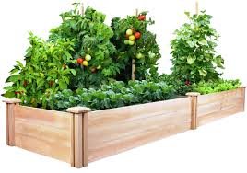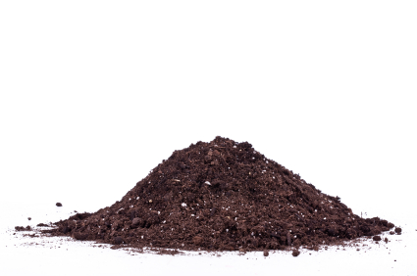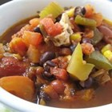

**69**

**2**

Recipes: Main Dishes

**Vegetarian Chilly**

### 1 tablespoon olive oil

### 1/2 medium onion, chopped

### 2 bay leaves

### 1 teaspoon ground cumin

### 2 tablespoons dried oregano

### 1 tablespoon salt

### 2 stalks celery, chopped

### 2 green bell peppers, chopped

### 2 jalapeno peppers, chopped

### 3 cloves garlic, chopped

### 2 (4 ounce) cans chopped green chile peppers, drained

### 2 (12 ounce) packages vegetarian burger crumbles

### 3 (28 ounce) cans whole peeled tomatoes crushed

### 1/4 cup chili powder

### 1 tablespoon ground black pepper

### 1 (15 ounce) can kidney beans, drained

### 1 (15 ounce) can garbanzo beans, drained

### 1 (15 ounce) can black beans

### 1 (15 ounce) can whole kernel corn

### Heat the olive oil in a large pot over medium heat. Stir in the onion, and season with bay leaves, cumin, oregano, and salt. Cook and stir until onion is tender, then mix in the celery, green bell peppers, jalapeno peppers, garlic, and green chilly peppers. When vegetables are heated through, mix in the vegetarian burger crumbles. Reduce heat to low, cover pot, and simmer 5 minutes,

### Mix the tomatoes into the pot. Season chilly with chili powder and pepper. Stir in the kidney beans, garbanzo beans, and black beans. Bring to a boil, reduce heat to low, and simmer 45 minutes. Stir in the corn, and continue cooking 5 minutes before serving.

**Organic Fertilizer 5-5-5**

### Organic fertilizer 5-5-5 is one of the best fertilizers used for organic gardening. It contains nutrients needed for healthy plant growth. Nitrogen, phosphorus and potassium are the main nutrients plants need for growth, which is in Fertilizer 5-5-5. This soil is granular which allows it to be a healthy for a long times. Organic fertilizers are beneficial soils because it converts organic fertilizers into soluble nutrients that can be absorbed by plants.

**Seaweed**

Seaweed can be useful as compose in fertilizer because it contains sixty micronutrients such as iron, copper, zinc, boron, and manganese. Seaweed also contains a high concentration of natural growth hormones. This allows plant growth hormones to stimulate root growth and increase fruit growth. Seaweed also increases frost resistance and improves storage life. Seaweed is very beneficial because it contains antitoxins that help plants fight off bacteria, viruses and pests.

Tips and Tricks for Successful Gardening

**68**

**3**

Tips and Tricks for Successful Gardening

Recipes: Main Dishes

**Quinoa with Chickpeas and Tomatoes**

### 1 cup quinoa

### 1/8 teaspoon salt

### 1 3/4 cups water

### 1 cup canned chickpeas, drained

### 1 tomato, chopped

### 1 clove garlic, minced

### 3 tablespoons lime juice

### 4 teaspoons olive oil

### 1/2 teaspoon ground cumin

### 1 pinch salt and pepper to taste

### 1/2 teaspoon chopped fresh parsley

### Place the quinoa in a fine mesh strainer, and rinse under cold, running water until the water no longer foams. Bring the quinoa, salt, and water to a boil in a saucepan. Reduce heat to medium-low, cover, and simmer until the quinoa is tender, 20 to 25 minutes.

### Once done, stir in the garbanzo beans, tomatoes, garlic, lime juice, and olive oil. Season with cumin, salt, and pepper. Sprinkle with chopped fresh parsley to serve.

### 3 Cups

* By using old CDs one can create a repellent to unwanted pests such as squirrels and mice. By hanging a CD by a string (preferably a fishing line so as to be less visible), the glare from the sun will keep out a large variety of rodents and protect your garden from potential damage.
* A great alternative to chemical herbicides is cornmeal. It is a natural substitute that can be used to kill ants and weeds without the threat of toxic chemicals.
* A great way to deter slugs, snails, and other bugs is by sprinkling crushed eggshells around the base of the plants. This way the sharp eggshells will prevent bugs from nibbling on your garden.
* Another way to keep out slugs is by gluing pennies to a bowling ball and placing it in your garden. Not only is it a funny project to do with your kids, but it also keeps out slugs and makes hydrangeas blue.
* As you plant seeds, you can put Epsom salt and sugar (in a 4:1 ratio) into each hole for a homemade miracle grow. Measure in teaspoons.

### 

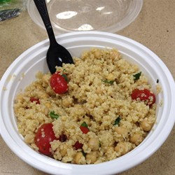

**67**

**4**

Raised Garden Beds

Raised garden beds are great for growing small plots of veggies and flowers. They keep pathway weeds from your garden soil, prevent soil compaction, provide good drainage and serve as a barrier to pests such as slugs and snails. The sides of the beds keep garden soil from being eroded or washed away during heavy rains. In many regions, gardeners are able to plant earlier in the season because the soil is warmer and better drained when it is above ground level.

Another great benefit of raised beds is that they reduce back strain. Gardening usually requires a lot of bending over in order get close to the ground, however because the soil is elevated, it isn’t necessary to bend over nearly as much. This may certainly appeal to some of the older or less mobile gardeners out there.

**Pasta with Scallops, Zucchini and Tomatoes**

### 1 pound dry fettuccine pasta

### 1/4 cup olive oil

### 3 cloves garlic, minced

### 2 zucchinis, diced

### 1/2 teaspoon salt

### 1/2 teaspoon crushed red pepper

### 1 cup chopped fresh basil

### 4 tomatoes, chopped

### 1 pound bay scallops

### 2 tablespoons grated Parmesan cheese

### n a large pot with boiling salted water cook pasta until al dente. Drain.

### Meanwhile, in a large skillet heat oil, add garlic and cook until tender. Add the zucchini, salt, red pepper flakes, dried basil (if using) and sauté for 10 minutes. Add chopped tomatoes, bay scallops, and fresh basil (if using) and simmer for 5 minutes, or until scallops are opaque.

### Pour sauce over cooked pasta and serve with grated Parmesan cheese.

### 8 Servings

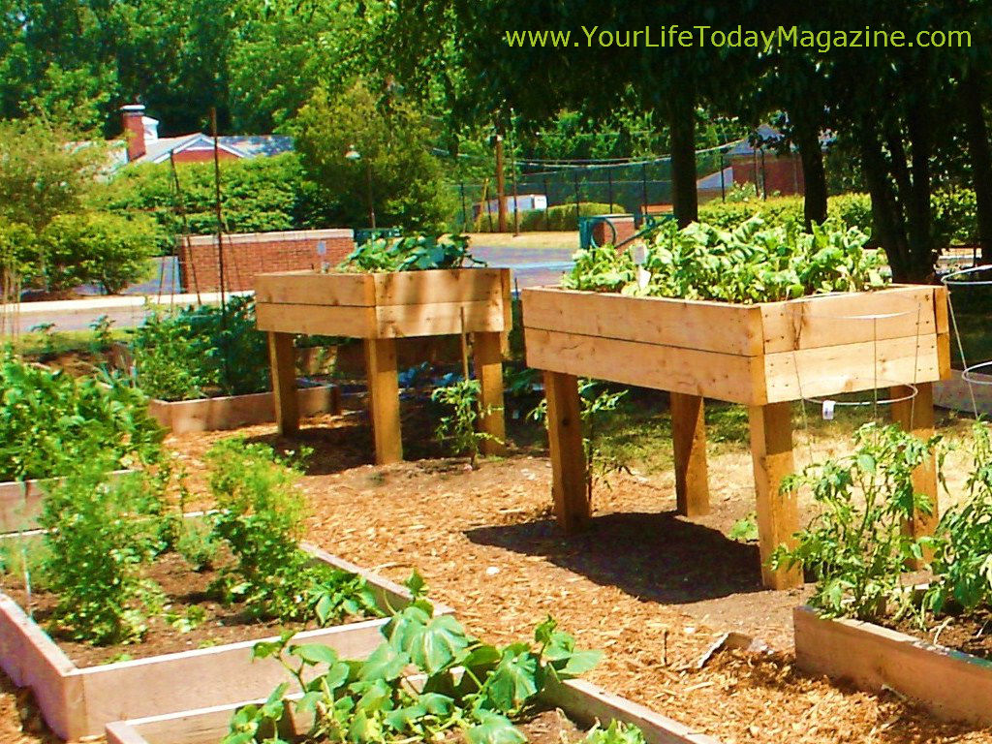

**66**

**5**

Cucumber Trellis

Recipes: Main Dishes

Cucumbers thrive most when encouraged to grow both vertically and horizontally. In order to grow vertically however, they must have something to climb up. A cucumber trellis allows them to grow to be thick and juicy. They can be purchased at most gardening retailers, however they are also relatively simple to build using PVC pipes (pictured below).

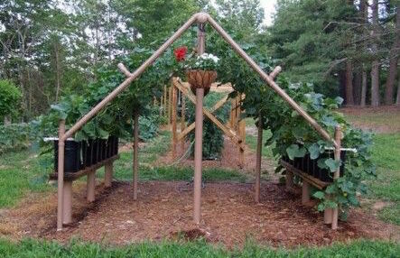

**Moroccan Lentil Soup**

### 2 onions, chopped

### 2 cloves garlic, minced

### 1 teaspoon grated fresh ginger

### 6 cups water 1 cup red lentils

### 1 (15 ounce) can garbanzo beans, drained

### 1 (19 ounce) can cannellini beans

### 1 (14.5 ounce) can diced tomatoes

### 1/2 cup diced carrots

### 1/2 cup chopped celery

### 1 teaspoon garam masal

### 1 1/2 teaspoons ground cardamom

### 1/2 teaspoon ground cayenne pepper &1/2 teaspoon ground cumin

### 1 tablespoon olive oil

### In large pot sauté; the onions, garlic, and ginger in a little olive oil for about 5 minutes.

### Add the water, lentils, chickpeas, white kidney beans, diced tomatoes, carrots, celery, garam masala, cardamom, cayenne pepper and cumin. Bring to a boil for a few minutes then simmer for 1 to 1 1/2 hours or longer, until the lentils are soft

### Puree half the soup in a food processor or blender. Return the pureed soup to the pot, stir and enjoy! (8 servings)

**65**

**6**

Vegetables and Plants to Grow in May and June

May and June are very similar in the types of vegetables that are best to plant. By the start of June, the soil is warmed up by the sun and so it is ready to provide nutrients that will allow the vegetables to grow to be ripe and juicy. By planting similar vegetables in June then by late August and Early September we can have a second harvest of the most flavorful veggies and fruits.

* **Broccoli**
  + Broccoli should be planted in a moderately sunny spot in the garden. It is common to grow broccoli inside for a few weeks before transplanting them.
* **Cucumber**
  + Cucumber plants can be grown as vines or in the form of bush plants. Seeds should be planted every few inches apart.
* **Peppers**
  + Pepper plants enjoy a lot of sun and a lot of water so it is important to keep the soil moist. Sometimes it is harder for seeds to germinate so it is important to plant them Mid-to-Late Spring.
* **Beans and Peas**
  + Beans and peas grow well in well-drained soil and are very easy to care for making them a favorite for gardeners.

**Other Plants/Vegetables** to consider may include: sunflowers, eggplants, tomatoes, herbs (oregano, chives, thyme, basil, etc.), watermelon, and pumpkin.

**Grilled Cilantro Salmon**

### 1 bunch cilantro leaves, chopped

### 2 cloves garlic, chopped

### 2 cups honey

### juice from one lime

### 4 salmon steaks

### Salt and pepper to taste

### In a small saucepan over medium-low heat, stir together cilantro, garlic, honey, and lime juice. Heat until the honey is easily stirred, about 5 minutes. Remove from heat, and let cool slightly.

### Place salmon steaks in a baking dish, and season with salt and pepper. Pour marinade over salmon, cover, and refrigerate 10 minutes.

### Preheat an outdoor grill for high heat. Lightly oil grill grate. Place salmon steaks on grill, cook 5 minutes on each side, or until fish are easily flaked with a fork.

### 6 servings

### 

Recipes: Main Dishes

**64**

**7**

Plants and Vegetables to Grow in July and August

Recipes: Main Dishes

Although the number of vegetables that one might grow becomes limited as the summer months continue, there are still some great vegetables to plant for your late harvest. Here is a list of vegetables for July and August:

* Carrots
* Planting carrots by mid-July yields a fall crops that will keep in the garden until used.
* Kale
* Planting kale mid-July through mid-August will yield an excellent harvest in the fall and winter.
* Other already mentioned vegetables and plants include bean (both bush and pole beans now that the soil is warmed up), broccoli (which can be planted as late as the start of fall), and cucumbers (vine or bush).

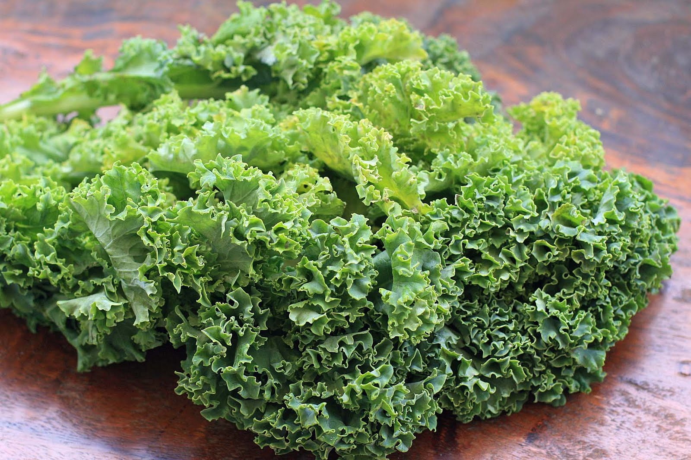

**Greek Chicken Pasta**

### 1 (16 ounce) package linguine pasta

### 1/2 cup chopped red onion

### 1 tablespoon olive oil

### 2 cloves garlic, crushed

### 1 pound skinless, boneless chicken breast meat - cut into bite-size pieces

### 1 (14 ounce) can marinated artichoke hearts, drained and chopped

### 1 large tomato, chopped

### 1/2 cup crumbled feta cheese

### 3 tablespoons chopped fresh parsley

### 2 tablespoons lemon juice

### 2 teaspoons dried oregano salt and pepper to taste

### 2 lemons, wedged, for garnish

### 1. Bring a large pot of lightly salted water to a boil. Cook pasta in boiling water until tender yet firm to the bit, 8 to 10 minutes; drain.

### 2. Heat olive oil in a large skillet over medium-high heat. Add onion and garlic; sauté until fragrant, about 2 minutes. Stir in the chicken and cook, stirring occasionally, until chicken is no longer pink in the center and the juices run clear, about 5 to 6 minutes

### 3. Reduce heat to medium-low; add artichoke hearts, tomato, feta cheese, parsley, lemon juice, oregano, and cooked pasta. Cook and stir until heated through, about 2 to 3 minutes. Remove from heat, season with salt and pepper, and garnish with lemon wedges. 6 servings

### 

**63**

**8**

**Eggplant tomato Bake**

### 1/2 cup all-purpose flour

### 1/2 cup dry breadcrumbs

### 2 tablespoons Italian seasoning

### 2 eggs

### 2 tablespoons water

### 1 small eggplant, sliced into 1/4 inch rounds

### 1 tablespoon peanut oil

### 1 (14 ounce) jar spaghetti sauce

### 1 cup ricotta cheese & 1 cup grated Parmesan cheese

### 1 tomato, thinly sliced

### 1 (8 ounce) package angel hair pasta

### 1 Preheat the oven to 350 degrees F (175 degrees C.

### 2. In a plastic bag, combine the flour, breadcrumbs and Italian seasoning. Shake to mix. In a shallow bowl, whisk together the eggs and water. Heat the oil in a large skillet over medium-high heat. There should be enough oil to thinly coat the bottom of the skillet. Dip the eggplant slices in egg, then place in the bag and shake to coat. Fry the slices in the skillet until golden brown on each side. Remove, and drain on paper towels.

### 3. Spread a thin layer of spaghetti sauce in the bottom of a 9 inch square baking dish. Cover with the eggplant slices, then top with more sauce. Mix together the ricotta cheese and Parmesan cheese; spread over the eggplant. Spread sauce over the cheese, and top with tomato slices. Cover with more sauce, and spread remaining cheese over the top.

### 4. Bake for 30 minutes in the preheated oven, or until cheese is melted and sauce is bubbling.

### 5. Meanwhile, bring a large pot of lightly salted water to a boil. Add the pasta, and cook for about 3 minutes, or until tender. Drain. Serve the eggplant tomato bake over past.

### 4 servings

**Companion Planting**

**Good Companion**

Beans & Squash

Eggplant & Beans

Tomatoes, Basil &Onions

Spinach, Chard & Onions

**Combinations to avoid**

Beans with onions and garlic

Onions with beans

### 

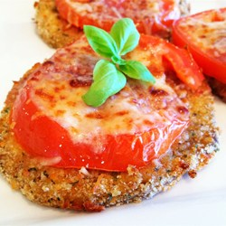

Recipes: Main Dishes

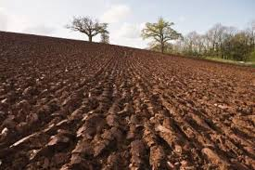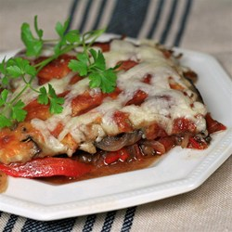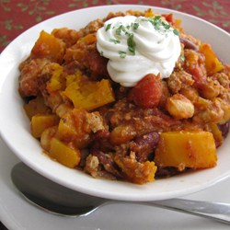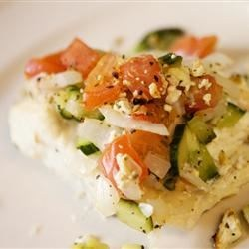

**62**

**9**

**Eggplant Rollatini**

### 1 eggplant, peeled and cut lengthwise into 1/4 inch slices

### 1 egg, beaten

### 1 cup Italian seasoned breadcrumbs

### 2 tablespoons olive oil

### 1 cup ricotta cheese 10 slices prosciutto

### 1 (14 ounce) jar spaghetti sauce

### 2 cups shredded mozzarella cheese

### 1 pound angel hair pasta

### Dip the eggplant slices in egg, then coat with breadcrumbs. Heat the olive oil in a large skillet over medium-high heat. Fry the eggplant on each side until golden brown. Remove to a paper towel lined plate to drain. Preheat the oven to 350 degrees F (175 degrees C.

### Spread a thin layer of ricotta cheese onto each slice of eggplant. Place a slice of prosciutto onto each one. Roll up tightly, and place seam side down in a 9x13 inch baking dish. Pour spaghetti sauce over the rolls, and top with shredded mozzarella cheese.

### Bake for 15 minutes in the preheated oven, until the cheese is melted and lightly browned.

### While the eggplant rolls are baking, bring a large pot of lightly salted water to a boil. Add the angel hair pasta, and cook for 2 to 3 minutes, until tender. Drain. Serve eggplant rolls and sauce over pasta. (4 servings)

**Soil and Nutrients**

Agriculture lime

Rock phosphate

Greensand

Compost

Shredded Leaves

Cover Crops

Seaweed – contains sixty micronutrients including iron, copper, zinc, boron and magnesium.

Nitrogen- protein to produce new tissue

Phosphorus- soil pH 6.5- 6.8 it stimulates growth

Potassium- Makes crops grow vigorously. Makes carbohydrates and provides disease resistance.

Planting

Recipes: Main Dishes

**61**

**10**

**Eggplant and Red Pepper Bake**

### 1 red bell pepper, cut into matchstick-sized pieces

### 1 small onion, cut into matchstick-sized pieces

### 4 cloves garlic, minced

### 1 teaspoon dried basil

### 1/4 teaspoon dried rosemary

### salt and ground black pepper to taste

### 3 1/3 tablespoons olive oil and balsamic vinegar

### 1 eggplant, sliced lengthwise 3/8-inch thick

### 2 tablespoons olive oil, or as needed

### 1/4 cup grated mozzarella cheese

### Preheat oven to 325 degrees F (165 degrees C).

### Mix red bell pepper, onion, and garlic in a large mixing bowl; season with basil, rosemary, salt, and pepper. Drizzle olive oil and balsamic vinegar over the pepper mixture; toss to coat the vegetables evenly. Brush eggplant slices with olive oil to coat thinly.

### Spread about 1/3 of the pepper mixture into the bottom of a square glass baking dish; top with a layer of about 1/3 of the eggplant. Repeat layering twice more. Top final layer with mozzarella cheese.

### Bake in preheated oven until the cheese is browned and the vegetables are bubbling, 35 to 40 minutes. (4 servings)

**Depths of Roots**

**4-5 inches**

Basil

Cilantro

**12-18 inches**

Arugula

Broccoli

Dill

Garlic

Lettuce

Onions

Parsley

Radishes

**18-24 inches**

Beans, Pole and Snap

Beets

Cayenne Pepper

Cucumber

Eggplant

Kale

Red Peppers

Squash

Swiss Chard

Zucchini

**24-36 inches**

Tomatoes

Planting

Recipes: Main Dishes

**60**

**11**

**Butternut Squash and Turkey Chilly**

### 2 tablespoons olive oil

### 1 onion, chopped

### 2 cloves garlic, minced

### 1 pound ground turkey breast

### 1 pound butternut squash - peeled, seeded and cut into 1-inch dice

### 1/2 cup chicken broth

### 1 (4.5 ounce) can chopped green chilies

### 2 (14.5 ounce) cans petite diced tomatoes

### 1 (15 ounce) can kidney beans with liquid

### 1 (15.5 ounce) can white hominy, drained

### 1 (8 ounce) can tomato sauce

### 1 tablespoon chili powder

### 1 tablespoon ground cumin and garlic

### Heat the olive oil in a large pot over medium heat. Stir in the onion and garlic; cook and stir for 3 minutes, then add the turkey, and stir until crumbly and no longer pink.

### Add the butternut squash, chicken broth, green chilies, tomatoes, kidney beans, hominy, and tomato sauce; season with chili powder, cumin, and garlic salt. Bring to a simmer, then reduce heat to medium-low, cover, and simmer until the squash is tender, about 20 minutes. (12 Cups)

**Basil**

### Basil is an herb that is easy to grow due to its adaptable qualities. Basil grows best in hot weather. Seeds should be planted in warm soil around 65 to 70 degrees. Cool weather will slow down the process of the plant’s growth. Many prefer to grow basil 3-4 weeks indoor, then transfer it into the garden once with weather is warm. Once seeding occurs and leaves are visible it is best to transfer two plants per pot. For the first several days it is best to avoid wind and sun light since Basil plants are sensitive. Basil is best grown in organic fertilizer that is lightly moist, acidic and well-drained soil. Basil is a good companion for tomatoes and benefits from tomatoes as they mature and provides shade to the basil leaves. In order to produce a lot of basil with tender and flavorful basil leaves it is recommended to pinch back the tip of each branch, when the plants are around 6 inches tall. It is also important to pinch back the branches throughout the harvest and any flowers that start to form. Basil is a great herb to grow due to the fact it produces high quaintly of leaves right up to frost. Freshly picked basil leaves can be added to many dishes such as salads, sandwiches and pastas and other food for flavoring.

Health Benefits of Fruits and Vegetables

Recipes: Main Dishes

**12**

**59**

**Butternut Squash Pizzas and Rosemary**

### 1 cup thinly sliced onion

### 1/2 butternut squash - peeled,

### seeded, and thinly sliced

### 1 teaspoon chopped fresh rosemary

### salt and black pepper to taste

### 3 tablespoons olive oil

### 

### 1 (16 ounce) packagerefrigerated pizza crust dough, divided

### 1 tablespoon cornmeal

### 2 tablespoons grated Asiago or Parmesan cheese

### Preheat oven to 400 degrees F (205 degrees C). Place sliced onion and squash in a roasting pan. Sprinkle with rosemary, salt, pepper, and 2 tablespoons of the olive oil; toss to coat.

### Bake in the preheated oven for 20 minutes, or until onions are lightly browned and squash is tender; set aside.

### Increase oven temperature to 450 degrees F (230 degrees C). On a floured surface, roll each ball of dough into an 8 inch round. Place the rounds on a baking sheet sprinkled with cornmeal (you may need 2 baking sheets depending on their size). Distribute squash mixture over the two rounds and continue baking for 10 minutes, checking occasionally, or until the crust is firm. Sprinkle with cheese and remaining tablespoon olive oil. Cut into quarters, and serve. (4 servings)

**Basil**

### Basil is 1 calorie per 2 table spoons

### Contains a good supply of Vitamin A, K, and C

### Rich in Antioxidants

### Rich in Iron, Magnesium, Calcium and Potassium

### Reduces Inflammation and Swelling

### 

Health Benefits of Fruits and Vegetables

Recipes: Main Dishes

**58**

**13**

**Broccoli and Rice Stir Fry**

### 1 1/2 cups uncooked long-grain rice

### 1 tablespoon vegetable oil

### 1 (16 ounce) package frozen broccoli florets, thawed

### 3 green onions, diced

### 2 eggs, beaten

### 2 tablespoons soy sauce

### 1/2 teaspoon salt

### 1/4 teaspoon ground black pepper

### In a saucepan, bring 3 cups water to a boil. Stir in rice. Reduce heat, cover, and simmer for 20 minutes.

### Heat oil in a large skillet over medium heat. Saute broccoli until tender crisp, and add scallions. Remove from skillet. Scramble eggs; return broccoli mixture to pan. Stir in cooked rice, soy sauce, salt and pepper.

### 8 servings

### 

**Beans**

### Beans such as green beans, pole beans and bush beans are fruits that taste the same but are grown differently. Bush beans grown in a short bushy plant that allow the beans to all ripe at once. Pole beans grow in long vines about 5-8 feet long that twine up a pole. Beans are produced over a two-month period. Pole beans can produce beans for 60 to 8 weeks if they are kept well picked and have a good vertical support. As soon as this plant comes out of the soil it looks for support to twine around so it is best to provide support as soon as you plant the seed. Bush beans are produced into a sturdy 2 ft. tall plant. It is important to pick the beans every day or two in order to produce beans every 3 to 4 weeks. When the plant stops producing beans you can grow a late summer plant like lettuce, beets or fall greens. Sun light with about1 inch of water each week is ideal for this plant. Beans absorb nutrients from the air via nitrogen-fixing bacteria. Bean plants are susceptible to a number of fungal diseases so it is important to keep the plant as dry as possible and avoid touching it when it’s wet with rain or dew. Good air circulation around the plant is also important avoid fungal problems.

Health Benefits of Fruits and Vegetables

Recipes: Main Dishes

**14**

**57**

**Baked Halibut Steaks**

### 1 teaspoon olive oil

### 1 cup diced zucchini

### 1/2 cup minced onion

### 1 clove garlic, peeled and minced

### 2 cups diced fresh tomatoes

### 2 tablespoons chopped fresh basil

### 1/4 teaspoon salt

### 1/4 teaspoon ground black pepper

### 4 (6 ounce) halibut steaks

### 1/3 cup crumbled feta cheese

### Reheat oven to 450 degrees F (230 degrees C). Lightly grease a shallow baking dish.

### Heat olive oil in a medium saucepan over medium heat and stir in zucchini, onion, and garlic. Cook and stir 5 minutes or until tender. Remove saucepan from heat and mix in tomatoes, basil, salt, and pepper.

### Arrange halibut steaks in a single layer in the prepared baking dish. Spoon equal amounts of the zucchini mixture over each steak. Top with feta cheese.

### Bake 15 minutes in the preheated oven, or until fish is easily flaked with a fork.

### 4 servings

Recipes: Main Dishes



Health Benefits of Fruits and Vegetables

**56**

**15**

**Swiss Chard With Garbanzo Beans and Fresh Tomatoes**

### 2 tablespoons olive oil

### 1 shallot, chopped

### 2 green onions, chopped

### 1/2 cup garbanzo beans, drained

### Salt and pepper to taste

### 1 bunch red Swiss chard, rinsed and chopped

### 1 tomato, sliced

### 1/2 lemon, juiced

### Heat olive oil in a large skillet. Stir in shallot and green onions; cook and stir for 3 to 5 minutes, or until soft and fragrant. Stir in garbanzo beans, and season with salt and pepper; heat through. Place chard in pan, and cook until wilted. Add tomato slices, squeeze lemon juice over greens, and heat through. Plate, and season with salt and pepper to taste.

### 4 servings

### 

Recipes: Appetizers

Health Benefits of Fruits and Vegetables

**Beets**

### Beets are vegetables that are easily grown since it does not attract that many pests or disease. The seeds can be scattered and the plants will grow for about 6-8 weeks. Beets are best grown when the seeds are directly planted into the garden. Since beet seeds have a hard outer coat it takes several days or even a week for the outer seed coat to break and allow seeds inside to germinate. It is important for the soil to be moist during this period to help soften the outer coat of the seeds. Beets usually yield about 9 plants per square foot. Full sun and 1 inch of water each week is ideal for the growth of this plant. Beets can be planted in early spring since they can tolerate the cold. Beets are tender and flavorful when the roots are about 4 or 5 inches across. Beets can tolerate the fall temperatures to about 20 degrees.

**16**

**55**

**Pico De Gallo**

### 1 medium tomato, diced

### 1 onion, finely chopped

### 1/2 fresh jalapeno pepper, seeded and chopped

### 2 sprigs fresh cilantro, finely chopped

### 1 green onion, finely chopped

### 1/2 teaspoon garlic powder

### 1/8 teaspoon salt

### 1/8 teaspoon pepper

### In a medium bowl, combine tomato, onion, jalapeno pepper (to taste,) cilantro and green onion. Season with garlic powder, salt and pepper. Stir until evenly distributed. Refrigerate for 30 minutes.

### 4 servings

### 

**Beets**

### 1 cup is 59 calories

### Contains a good supply of Vitamin A, B and C

### Rich in Magnesium, Iron, Potassium and Fiber

### Rich in Beta- Carotene, Beta- Cyanine and Folic Acid

### Helps cleanse your body

### Lowers your Blood Pressure

### Boost your Stamina

### Reduces Inflammation

### Contains Anti- Cancer properties

### 

Health Benefits of Fruits and Vegetables

Recipes: Appetizers

**54**

**17**

**Mock Tuna Salad**

### 1 (19 ounce) can garbanzo beans (chickpeas), drained and mashed

### 2 tablespoons mayonnaise

### 2 teaspoons spicy brown mustard

### 1 tablespoon sweet pickle relish

### 2 green onions, chopped

### salt and pepper

### In a medium bowl, combine garbanzo beans, mayonnaise, mustard, relish, chopped green onions, salt and pepper. Mix well.

### 4 servings

### 

**Broccoli**

### Broccoli is a vegetable that is easily grown and doesn’t require a lot of work. This plant grows best in moist rich soil and cool temperatures. It is best to plant the seeds indoor s under light then transfer the plant into the garden around the last week of spring. One large head will be produced in the center of the plant with edible side shoots. When the central head has fully formed dark green buds it is ready to harvest. For the best flavor eat when the heads are compact. If you wait too long, the buds will start to open and turn yellow causing a bitter flavor. After a week or two the plant will begin forming smaller heads from the sides of the center stem. If you harvest the side shoots when the buds are still tight and green they will also be tasty as the first full-size head. The plant can keep producing for several months if you harvest the plant several times each week. The extreme cold is harmful to broccoli because it causes the central head to form small bitter knobs. If one runs into this dilemma you can cut off the deformed central head and the plant will still most likely keep producing a good crop of side shoots.

Health Benefits of Fruits and Vegetables

Recipes: Appetizers

**53**

**18**

**Mexican Cucumber Salad**

### 1 medium cucumber, chopped

### 1 (8.75 ounce) can whole kernel corn, drained

### 1 (16 ounce) can stewed tomatoes, drained and sliced

### 1 green bell pepper, chopped

### 1 red bell pepper, chopped

### 2 tablespoons red wine vinegar

### 1 tablespoon crushed red pepper flakes

### 1/2 teaspoon garlic, minced

### 1/2 teaspoon cumin

### 1/4 teaspoon dried cilantro

### 1/4 teaspoon salt

### 1/8 teaspoon ground black pepper

### In a large bowl, toss together the cucumber, corn, tomatoes, green bell pepper, red bell pepper, and red wine vinegar. Season with crushed red pepper flakes, garlic, cumin, cilantro, salt, and black pepper. Cover, and chill at least 30 minutes before serving. (6 servings)

**Broccoli**

### 1 cup is 50 calories

### 1 cup contains 2 grams of sugar, 2 grams of fiber and 3 grams of protein

### Contains a good supply of Vitamin A, C and K

### Rich in Folate and Potassium

### Decreases the risk of Obesity, Diabetes and Heart Disease

### Promotes a healthy skin complexion and hair

### 

Health Benefits of Fruits and Vegetables

Recipes: Appetizers

**19**

**52**

**Balsamic Bruschetta**

### 8 roma (plum) tomatoes

### 1/3 cup chopped fresh basil

### 1/4 cup shredded Parmesan cheese

### 2 cloves garlic, minced

### 1 tablespoon balsamic vinegar

### 1 teaspoon olive oil

### 1/4 teaspoon kosher salt

### 1/4 teaspoon freshly ground black pepper

### 1 loaf French bread, toasted and sliced

### In a bowl, toss together the tomatoes, basil, Parmesan cheese, and garlic. Mix in the balsamic vinegar, olive oil, kosher salt, and pepper. Serve on toasted bread slice.

### 8 servings

### 

**Cilantro**

### Cilantro is an herb that is quickly grown in warm temperatures. It is best to grow cilantro directly into the garden because they develop a taproot, which causes it to not be suitable for transplanting. Cilantro seeds take a few weeks to germinate but once that is obtained it grows rapidly. Cilantro require any fertilizer but for best result compost before planting. A lot of sunlight is also required for the growth of cilantro. It is important to pinch the stems back and begin harvest the leaves as soon as they are produced to avoid the plants from going to flower. It takes about 60 days for cilantro to form into flowers. Scatter a few cilantro seeds every three weeks to maintain a continuous supply of tender leaves. Cilantro usually comes back the following year. One can dry the seeds of the plant used it as different seasoning like coriander.

Health Benefits of Fruits and Vegetables

Recipes: Appetizers

**51**

**20**

**Baked Kale Chips**

### 1 bunch kale

### 1 tablespoon olive oil

### 1 teaspoon seasoned salt

### Preheat an oven to 350 degrees F (175 degrees C). Line a non-insulated cookie sheet with parchment paper.

### With a knife or kitchen shears carefully remove the leaves from the thick stems and tear into bite size pieces. Wash and thoroughly dry kale with a salad spinner. Drizzle kale with olive oil and sprinkle with seasoning salt.

### Bake until the edges brown but are not burnt, 10 to 15 minutes.

### 

**Cilantro**

### 1 cup is 4 calories

### 1 cup Contains 2 grams of sugar, 2 grams of fiber and 3 grams of protein

### Contains a good supply of Vitamin A, C and K

### Rich in Manganese, Choline, Folate and Potassium

### Rich in antioxidants beta- carotene, beta- cryptoxanthin, lutein and zeaxanthin

### Decreases the risk of Obesity, Diabetes and Heart Disease

### Promotes a healthy skin complexion and hair

### 

Health Benefits of Fruits and Vegetables

Recipes: Appetizers

**21**

**50**

**Zucchini**

### I cup is 21 calories

### 1 cup contains 1 grams of carbohydrates, 2 grams of protein and 4 grams of fiber

### Contains a good supply of Vitamin C, and B6

### Rich in Manganese, Potassium and Phosphorus

### Good supply of Water, 95% is made up of water

### Decreases the risk of Obesity, Diabetes, Cancers and Heart Disease

### Prevents Against Infections and Disease

### 

Health Benefits of Fruits and Vegetables

**Cucumber**

### Cucumber is a fruit that grows best in warm weather. It is best to plant cucumber in soil that is around 65 degrees. With warm weathers you can plant the seeds directly into the ground. If the weather is cool you can get a head start of gardening by planting the seeds 2-3 weeks in a pot indoors. The striped cucumber beetle is a serious threat to planting cucumbers due to the fact they eat newly germinated seeds. For best results it is best to start cucumber planting indoors to gives them time to develop and toughen up before they’re under attack by the striped cucumber beetle. It is important to pick your cucumbers as soon as they are developed in order to increase the production of cumbers. For the best tasting cucumbers it is important to keep the soil moist in order to avoid tough bitter cucumber. Cucumbers are the ultimate low-calorie snack because they are more than 95 percent water.

Health Benefits of Fruits and Vegetables

**49**

**22**

**Zucchini**

### Zucchini is a fruit that is easily grown. Constant moisture, sunlight and organic soil are important for the growth of zucchinis. To get a head start on growth you can start planting the seeds 3 deep in a pot indoors for about few weeks than and transfer them outside to the garden once the temperature is hot. In order to help retain moisture and reduce weeds one should add mulch around the bed. The plant should obtain about an inch of water per week. Zucchini plants produce flowers and the covers should be removed in order to allow the inserts to pollinate them. Harvest the zucchini plant once they are 6-8 inches long for the most flavorful taste.

Health Benefits of Fruits and Vegetables

**Cucumber**

### 1 cup is 10 calories

### 1 cup contains 115g of water, 1.8 grams of sugar, 0.9 grams of fiber, 0.2 grams of, 0.8 grams of protein and 2.9 grams of carbohydrates

### Contains a good supply of Vitamin A, C and K

### Rich in Magnesium, Manganese and Potassium

### Rich in Thiamin, Riboflavin, B-6, Folate, Iron, Phosphorous, Zinc and Copper

### Decreases the risk of Obesity, Diabetes and Heart Disease

### High water contents ward of Dehydration

### Decreases Swelling, Inflammation and Irritation

### 

Health Benefits of Fruits and Vegetables

**23**

**48**

**Tomato**

### I cup is 100 calories

### 1 cup contains 5 grams of carbohydrates, 1 grams of protein, 3 grams of sugar and 1 grams of fiber

### Contains a good supply of Vitamin A, C, and Folic acid

### Rich in Antioxidants including Alpha- Lipoic Acid, Lycopene, Choline, Beta- Carotene and Lutein

### 

### Decreases the risk of Obesity, Diabetes, Cancers and Heart Disease

### Reduces Blood Pressure and Diabetes

### Improves Skin Texture

### 

**Dill**

### Dill is an herb that is easy to grown. In about four to six weeks it reaches its full height of 2 to 3 feet. It is best to grow dill directly into the garden because they develop a taproot, which causes it to not be suitable for transplanting. One can plant dill by adding compost and sprinkling the seeds on the soil surface and watering it into the soil. It is important to keep the soil warm during germination, which can take about 7 to 21 days. It is important to mulch the soil with straw or leaves when the seedlings are 3-4 inches tall, to help conserve water and keep down the weeds. Once the plant is 6 inches tall you can start picking the leaves. Dill will produce yellow flowers once it reaches its full height. For a continuous supply plant a few dill seeds every three weeks. Dill can be used to flavor pickles it flavors, soups and other foods.

Health Benefits of Fruits and Vegetables

Health Benefits of Fruits and Vegetables

**47**

**24**

Health Benefits of Fruits and Vegetables

**Dill**

### 1 table spoon is 20 calories

### Contains a good supply of Vitamin A and C

### Rich in Iron, Manganese and Potassium

### Rich in Riboflavin and Folate

### Aids in digestion

### Reduces the risk of cancer and inflammation

### Improves immune system

### Reduces excessive gas and provided relief from diarrhea

### Cures Respiratory Disorders

### 

Health Benefits of Fruits and Vegetables

**Tomato**

### Tomatoes are a fruit that is easily grown in warm temperatures. If the weather is warm you plant the seeds directly into the garden, but if the soil is cool you can plant the seeds indoors. Tomatoes require a soil temperature of 70 degrees in order for germination to occur. Start planting the seeds 6-8 weeks in a pot indoors and transfer the plant to the garden once the weather is warm. The tomato plant should be exposed to 15 hours of light each day and should be fertilized frequently for ideal plant growth. To avoid fungal diseases you should mulch around your plant and avoid growing tomatoes in the same spot every year.

**25**

**46**

**Eggplant**

### Eggplants are a vegetable that ranges in color from a glossy purple to pure white. They also range in different shapes and sizes of long and thin or short and portly. Constant heat is important for the growth of Eggplants. It is important for the soil to be warm due to the fact seed germination will occur quicker the warmer the soil is. To get a head start on growth you can start planting the seeds in a pot indoors for about 8- 10 weeks and then transfer them outside to the garden once the temperature is hot. Cold temperatures will reduce the growth of the eggplant. Eggplants are best grown in soil that is not too high in nitrogen and acidic soil with a pH from 5.8 to 6.8. Each plant will produce between 4 to 6 fruits. For ideal growth one can place a few large dark-colored rocks near the plants so it can absorb heat during the day and radiate it back during the night.

Health Benefits of Fruits and Vegetables

Health Benefits of Fruits and Vegetables

**Swish chard**

### I cup is 33 calories

### 1 cup contains 7.2 grams of carbohydrates, 3.3 grams of protein, 0.2 grams of fat, 1.9 grams of sugar and 3.7 grams of fiber

### Contains a good supply of Vitamin A, C, K and E

### Rich in Thiamin, Iron, Phosphorous, Zinc Magnesium, Potassium and Manganese

### Contains Antioxidants Alpha and Beta- Carotene

### Decreases the risk of Obesity, Diabetes and Heart Disease

### Reduces Blood pressure

### Prevents Osteoporosis

### 

**45**

**26**

**Swiss Chard**

### Swiss chard is a vegetable that is easily grown due to the fact they are not bothered by pest or diseases. Swiss chard should be planted directly into the garden. For ideal growth Swiss chard should be obtain about an inch of water per week. Seeds should be planted four inches apart and grows best in soil that is rich in organic matter and have a pH of 6.0 to 7.0. When harvesting one can cut the plant about an inch above the ground. Chard has matured when the plant reaches a height of about 1 to 2 feet.

Health Benefits of Fruits and Vegetables

**Eggplant**

### 1 cup is 20 calories

### 1 cup Contains 2 grams of sugar, 2.5 grams of fiber, 0.8 grams of protein, 0.15grams of fat and 4.82 grams of carbohydrates

### Contains a good supply of Vitamin B-6 and C

### Rich in Magnesium, Iron and Potassium

### Rich in Antioxidants

### Decreases the risk of Obesity, Diabetes and Heart Disease

### Decreases Cholesterol

### Promotes a healthy skin complexion and hair

### 

Health Benefits of Fruits and Vegetables

**27**

**44**

**Summer Squash**

### I cup is 82 calories

### 1 cup contains 22 grams of carbohydrates, 1.8 grams of protein, 4 grams of sugar and 6.6 grams of fiber

### Contains a good supply of Vitamin A, C and E

### Rich in Thiamin, Folate, Magnesium, Potassium and Manganese

### Decreases the Risk of Obesity, Diabetes and Heart Disease

### Promotes a healthy skin complexion and hair

### Maintains Blood Pressure

### Decreases Cholesterol and Inflammation

### 

Health Benefits of Fruits and Vegetables

**Garlic**

### Garlic is a vegetable that is easily grown. Planting should take place 4 to 6 weeks in cool soil before the plant produces. In warm climates one can store garlic in the refrigerator for a couple of weeks before planting. Keeping the garlic cloves at temperatures below 40 degrees Fahrenheit is important because otherwise bulbs will fail to form. Although the time to harvest generally varies, October/November plantings will produce healthy harvests come May or June. Garlic signals it is ready for harvest when the tops are dry and have fallen over. Garlic requires compost and a little organic fertilizer. In order to plant garlic one should separate the cloves of a head or bulb of garlic and plant each clove about 2 inches deep into the soil with the pointy end up. It is important to space the bulbs 3-4 inches apart in rows that are 6-8 inches apart for ideal growing space. The biggest cloves will yield the biggest heads so it is important to keep in mind what size bulb you would like to plant.

Health Benefits of Fruits and Vegetables

**43**

**28**

**Summer Squash**

### Squash are fruits that are easy to grow and produce a lot of fruits. They also range in different shapes and sizes of long and thin or short and portly. Constant moisture, sunlight and organic soil are important for the growth of summer squashes. Summer squash need an inch of water a week. To get a head start on growth you can start planting the seeds 3-4 inches deep in a pot indoors for about few weeks than and transfer them outside to the garden once the temperature is hot. The summer squash taste best when it is tender and eaten young. Squash has flowers that are both male and female and once they reach the flowering stage, the covers come off to allow for pollination by insects. In order to help retain moisture and reduce weeds one should add mulch around the bed. The ideal time to harvest summer squash is when they are about 6 to 8 inches long and about 2 to 3 inches in diameter.

### 

**Garlic**

### 1 teaspoon is 4 calories

### Contains a good supply of Vitamin B-6 and C

### Rich in Magnesium, Iron and Potassium

### Reduces High Blood Pressure

### Treats Bronchitis, Tuberculosis, Diabetes and Fever

### Treats Coughs, Colds and Ear aches

### Aids in Digestion

### 

Health Benefits of Fruits and Vegetables

Health Benefits of Fruits and Vegetables

**29**

**42**

**Radishes**

### 1 tablespoon is 1 calorie

### 1 teaspoon contains 1 grams of carbohydrates, 1 grams of protein and 6 grams of fiber

### Contains a good supply of Vitamin A, K and C

### Rich in Zinc, Phosphorus, Copper, Potassium and Iron

### Improves Immune System

### Helps prevent Heart Disease, Gallbladder Infection, Colon, Stomach and Oral Cancer

### Reduces Pain, Swelling and Maintains Moisture in the Skin

### 

**Head Lettuce**

**Lettuce is a vegetable that is best grown in warm weather. Most varieties of lettuce will eventually form a head, but iceberg and romaine lettuce is grown specifically for a tight, central head. Lettuce seeds are tiny and are usually planted in a pot indoors at first for best results. The seeds should be planted one at a time and should not be covered with a lot of soil. This factor is important for growth due to the fact the seeds require a lot of sunlight in order to germinate. It is also important to press down on the seed after planting so it is in good contact with the soil but not to far. The seedlings can be transferred to be planted outdoors when they are four weeks old. In order to obtain nice big heads of lettuce one should plant one or two plants per square foot.**

Health Benefits of Fruits and Vegetables

Health Benefits of Fruits and Vegetables

**41**

**30**

Health Benefits of Fruits and Vegetables

**Head Lettuce**

### 1 cup is 5 calories

### 1 cup contains 20 ounces of water

### Contains a good supply of B Vitamins, Iron and Potassium

### Rich in Riboflavin, Thiamine Niacin, and Folate

### Decreases Cholesterol, Cancer Control, Protection of Neurons, Sleep Induction, Anxiety Control, lowering Inflammation

### Contains a large supply of Anti- oxidants

### 

**Radishes**

### Radishes are vegetables that are easily grown in cool temperatures. Radishes grow best in the spring and the fall. Avoid planting radishes in hot weather because they become bitter and woody with heat. They are ready to harvest in less than a month since they germinate in a few days. The standard radish will mature within 3-4 weeks. It is important to plant them no more than 3 inches apart in order to increase growth rate and obtain a nice shape. Radishes are best planted with peppers and parsley because they will be ready to harvest before the peppers or parsley need the space. Be sure to pick the radishes as soon as they are mature because the bigger they get the bitterer they become.

**31**

**40**

**Parsnip**

### 1 cup is 110 calories

### 1 cup contains 26 grams of carbohydrates, 2 grams of protein, 0 grams of fat and 6 grams of fiber

### Contains a good supply of Vitamin C, Potassium and Manganese

### Adds in weight loss

### Boosts immune system

### Beneficial for growth and development of the body

### Reduces cholesterol levels

### Helps prevent gastrointestinal disorder

**Hot Peppers**

### Hot peppers like is a fruit that is best grown in hot weather. It is best to plant hot peppers in soil that is around 60 degrees. If the weather is warm you plant the seeds directly into the garden, but if the soil is still cool you can plant the seeds indoors.

### Start planting the seeds 12 weeks in a pot indoors

### and transfer the plant to the garden once the weather is warm. Be careful not to over fertilize due to the fact the plant will produce more leaves then peppers. To stimulate more fruit production one can add wood ashes and granite dust around the soil. For best plant growth make sure the soil is dry and the plants are planted close together. The more ripped the pepper is the hotter it is. A pepper that is water less will also be hotter than a pepper that receives plenty of water.

Health Benefits of Fruits and Vegetables

Health Benefits of Fruits and Vegetables

**39**

**32**

**Parsnip**

### Parsnip is a vegetable that grows best in warm weather. It is important for the soil to be cool and shaded since the seeds germinate around this temperature. Parsnip seeds grow very slowly due to the fact it take two to three weeks for the seed to germinate. When planting parsnip seeds in the ground make sure to plant them 3 – 6 inches apart. It is important the plant receives about an inch of water per week. Parsnips mature in about 16 weeks and are ready to harvest then.

**Hot Peppers**

### 1 table spoon is 17 calories

### 1 cup Contains 2 grams of sugar, 2.5 grams of fiber, 0.8 grams of protein, 0.15grams of fat and 4.82 grams of carbohydrates

### Contains a good supply of Vitamin A, E and B6

### Rich in Iron, Phosphorus, Sodium and Copper

### Suppress your appetite and helps burn calories

### Treats aches and pains in your muscle and joints

### Reduces Inflammation

### Decreases the risk of Type Two Diabetes

### 

Health Benefits of Fruits and Vegetables

Health Benefits of Fruits and Vegetables

**33**

**38**

**Parsley**

### 1 tablespoon is 1 calorie

### 1 teaspoon contains 0.6 grams of carbohydrates, 0.3 grams of protein, 0.1 grams of fat, 0.1 grams of sugar and 3 grams of fiber

### Contains a good supply of Vitamin C, K and B6

### Prevents Diabetes and Cancer

### Improves Bone Health

### Decrease Tumor Size

### 

**Kale**

### Kale is a vegetable that grows in cool and moist temperatures. It is important for the soil to be cool around 45 degrees since the seeds germinate around this temperature. As the weather gets cooler the leaves are said to have more flavor. Kale only requires a little organic fertilizer due to the fact it is a moderate feeder. Mulch and shredded leaves around the plants helps provide ideal conditions for the plants. In about three months a full sized plant will be devolved.

Health Benefits of Fruits and Vegetables

Health Benefits of Fruits and Vegetables

**37**

**34**

**Parsley**

### Parsley is an herb that is easy to grow. It is important for the soil to be cool and shaded since the seeds germinate around this temperature.

### Parsley seeds grow very slowly due to the fact it take three to four weeks for the seed to germinate. In order to speed up the process of germination soak the seeds in warm water overnight before planting. Parsley can be harvest anytime and takes about 75 days for a mature plant.

**Kale**

### 1 cup is 33 calories

### 3 grams of protein and 2.5 grams of fiber

### Contains a good supply of Vitamin A, C and K

### Rich in Iron, Calcium, Fiber and Potassium

### Improves Blood Glucose Control in Diabetes

### Decreases the risk of Cancer, High Blood Pressure, and Asthma

### Reduces the risk of Heart Disease, Stroke and Kidney Stones

### Promotes a healthy skin complexion and hair

### 

Health Benefits of Fruits and Vegetables

Health Benefits of Fruits and Vegetables

**35**

**36**

**Onions**

### 1 cup is 33 calories

### 1 cup contains 15 grams of carbohydrates, 2 grams of protein, 7 grams of sugar and 3 grams of fiber

### Contains a good supply of Vitamin A and C

### Rich in Iron, Calcium, Folate, sulfur and Potassium

### Regulates Blood Sugar

### Reduces Heart Disease

### Lowers the risk of Several Cancers

### Improves your Mood

### Promotes a healthy skin complexion and hair

### 

Health Benefits of Fruits and Vegetables

**Onions**

### Onions are vegetables that grow in warm temperatures. It is important for the soil to be lose, sandy or contain a lot of compost. When planting onions into the ground the bulbs should be spaced about 3-4 inches apart from each other. The more crowed onions are kept together, the smaller they are in size. It is important to water them so they obtain about 1 inch of water a week to help maintain their shallow roots. It is also important to cut back the grassy growth and keep the stock at about 3 inches tall in order to allow the onion to receive more sulfur from the soil, which helps with the plant growth. Scallions are young onions that are bunched onions without bulbs. When the tops of onions are flopped over they are mature and ready to harvest.

Health Benefits of Fruits and Vegetables